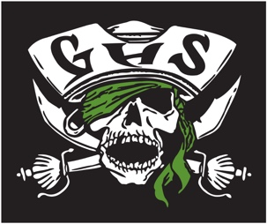

2020-2021 Girls Weightlifting Schedule

November 4th Gulf @ Anclote Weigh-ins 3:00 Lifting 3:45
1540 Sweetbriar Holiday

November 11th Gulf @ River Ridge Weigh-ins 2:45 Lifting 3:30
11646 Town Center Rd NPR

November 18th Gulf @ Mitchell Weigh-ins 3:00 Lifting 3:30
2323 Little Rd NPR
December 2nd Conference @ River Ridge Weigh-ins 3:30 Lifting 4:30
11646 Town Center Rd NPR

December 9th Gulf @ Hudson Weigh-ins 3:00 Lifting 3:45
14410 Cobra Way Hudson

December 11th Disparti Invitational @ River Ridge Weigh-ins 2:30 Lifting 4:30
11646 Town Center Rd. NPR

December 16th Gulf @ Fivay Weigh-ins 3:00 Lifting 3:45
12115 Chicago Ave Hudson

January TBD Districts @ River Ridge
(New Port Richey)

January TBD Regionals @ TBA TBA

February 12th States @ Arnold High School TBA
(Panama City Beach)

There is no charge for any in season meets. Conference, Disparti, Districts, Regionals and State meets there will be a gate admission those prices TBD.

Coaches: Bruno Buonsanto
Jimmy Fredrickson
Jordan Garrison

