Gulf High School Dress Code 2018-19

Thank you for supporting our dress code guidelines. The District School Board of Pasco County and Gulf High School administration have established these guidelines for student dress in order to promote an orderly learning environment and to prepare all students for career success. Please take a moment to review these expectations and plan accordingly to be in compliance with Gulf High School’s expectations during the school day. Should students not meet dress code expectations, we will assist with securing an appropriate change of attire. Parents may be contacted, as necessary, to ensure the student is properly dressed for the learning environment.

 | What NOT to wear!
Students will wear modest clothing. Sexually implicit or explicit clothing, bikinis, and see-through clothing are not permitted. No side/abdominal skin is to be exposed. | 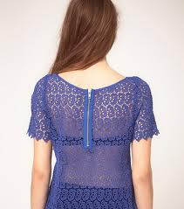  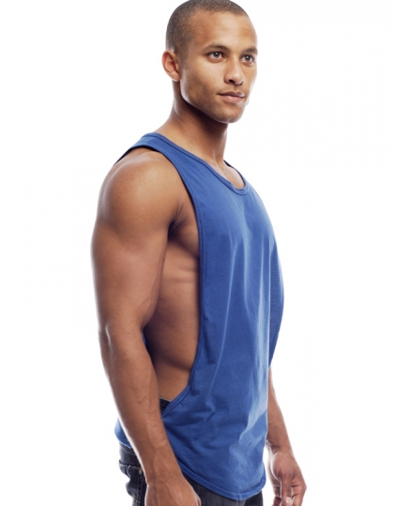
Any tops/shirts may not dip below a line formed between the right and left armpit. Tops must be long enough to clearly overlap the belt line or stay tucked in during movement. (No exposure of cleavage, stomach/side skin, or undergarments.) | 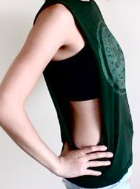  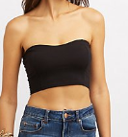  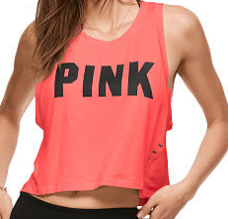
All shorts and skirts should be no shorter than 4 inches above the knee during typical movement. Torn jeans must not have holes higher than 4 inches above the knee. Track shorts, as well as most athletic shorts, are NOT appropriate clothing for school due to being too short. | 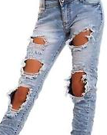
Pants will be worn securely at waist. No underwear is to be exposed. | 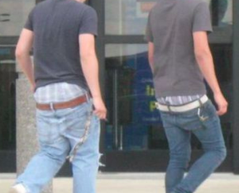  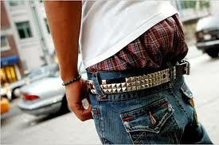
Clothing and accessories may not be worn that is offensive, insinuate profanity or contains derogatory/harassing remarks, identifies students with gangs or antisocial groups, or advertises tobacco, alcohol, or drugs. This includes pictures/images of people not in dress code. | 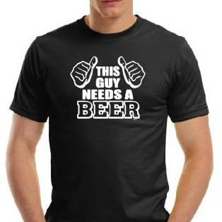
Students will not wear hats, hoodies, or head coverings (bandanas) on the school campus unless previously approved for medical or religious reasons or special school activities by the principal. | 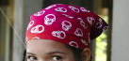  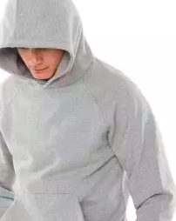
Students must wear shoes for foot protection and hygienic reasons while on school grounds or on school transportation. Slippers are not acceptable. (Need to have a hard sole.)  Pajamas or other costumes may be worn only on designated dress-up days however, face paint is never permissible, nor are masks.  Jewelry will be worn in a safe and non-disruptive manner. Wallet chains, spiked jewelry, and dog collars are not permitted. | 