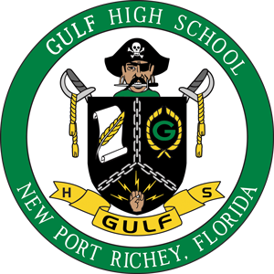
Gulf High School
2019 Curriculum Fair

Please join us on Monday, February 11th from 6pm-7:30pm for our annual curriculum fair. This is an opportunity for students and families to see the exciting instruction and learning students will demonstrate in their courses during the 2019-2020 school year. We will also have information about athletics, clubs and organizations.

We will be having 3 breakout sessions.
Academy Breakout-Room 109 6:15pm and 6:45pm
IB/AP Breakout-Media 6:15pm and 6:45pm
First Time AP-Invitation Only Current GHS Students 6:30pm-Band Room

