All school choice options including International Baccalaureate (IB), Cambridge, STEM, Collegiate High School, and Wendell Krinn Technical High School have been combined into one timeframe for secondary schools.

The Pasco Pathways Application windows are listed below

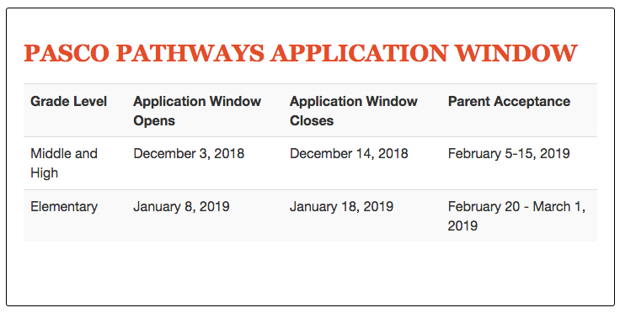

If you are interested in the IB Program at Gulf High School;

- Complete the online application at :
http://www.pasco.k12.fl.us/ed_choice

- Attend the writing and math test on Saturday, December 15th, at 9am in the cafeteria. Please bring two pens, a #2 pencil, and three sheets of notebook paper.
- Refer to the application window above for notification dates.

If you have any questions about the IB Program at GHS, please email Ms. Burkette at tburkett@pasco.k12.fl.us or call at 727-774-3335.

