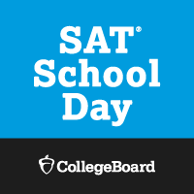
Open to Grades: 10-12
Got to work on the weekends?
Have no transportation?

Take the SAT Test during
the school day on
Tuesday, April 24, 2018.

​

​

